**The Ohio State University College of Veterinary Medicine Class of 2028 Student Government Association (SGA)**

**General Information**

**Target Demographics**

The Student Government Association (SGA) for the Class of 2028 represents and advocates for the students enrolled in the Ohio State College of Veterinary Medicine. Our primary focus is to support academic success, enhance student well-being, and foster professional development through leadership, collaboration, and community engagement. We serve all members of the Class of 2028, ensuring their voices are heard within the college and beyond.

**Contact Information**

For questions, concerns, or to get involved, please reach out to us via:  
📧 Email: Class President- mohan.195@osu.edu  
📱 Social Media: SGA Instagram- @tosucvm28  
📍 Location: Veterinary Medical Academic Building, 1900 Coffey Rd, Columbus, OH 43210

**Organization Photo and Logo**

**Additional Details**

* Meetings: Regular meetings are held monthly and are open to all SGA members, the faculty advisor, administrators, and any members of the class of 2028.
* Events & Initiatives: We organize social events, wellness programs, academic support sessions, and networking opportunities. Some examples are Vet Gala, Fur Ball, Dodge Ball for Dues, Big-Little Social.
* Committees: Our SGA includes various committees focusing on student life, academics, professional development, and outreach. Some examples are Vet Gala and Fur Ball committees.
* Collaboration: We work closely with faculty, staff, and other student organizations to enhance the veterinary student experience.

For the latest updates, be sure to follow us on our social media channels or contact us directly. We look forward to serving and supporting our fellow students throughout our journey at Ohio State!

**Roster**

President- Abbey Mohan

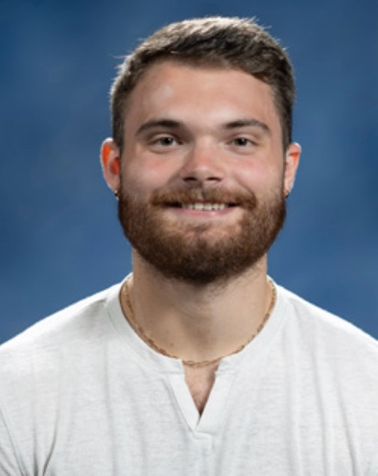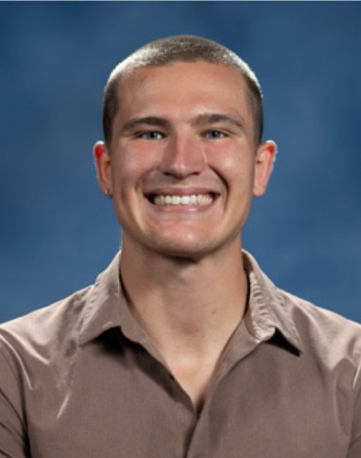Vice Presidents- Colin Sabo and Nathan Swartz

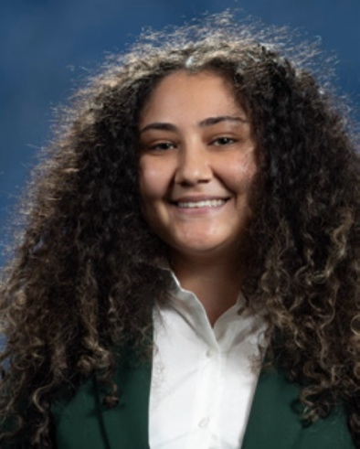Treasurer- Aya Hassan

Secretary- Allison Barr

Legislative Director- Linda Cho

Historian- Jacqueline Pacheco



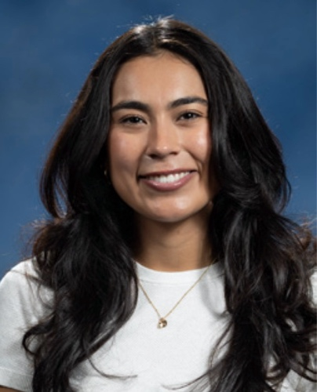Fundraising and Merchandise Chairs- Nayalise Puentes and Emma Walters

Creative Design Chair- Sydney Shair

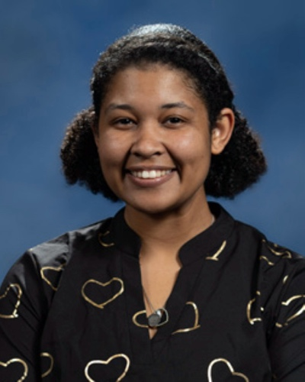Diversity and Inclusion Chairs- Xiaoyu Zhou and Faith Alvarez

Wellness Committee- Sarah Starkey

Faculty Advisor- Teresa Burns

**Goals**

1. To have $1,000 heading into Fur Ball planning.

2. Create a class Instagram.

3. Establish Big-Little program.

4. Get more feedback from the class.

5. Increase various cultural celebration and support.

6. Roll out at least one merch design before the start of fall 2025 semester.

**Constitution**

**Article I: Name**

The name of this organization shall be **The** **Ohio State University College of Veterinary Medicine Class of 2028 Student Government Association (SGA)**.

**Article II: Purpose Statement**

The purpose of the SGA is to represent the interests of the Ohio State University College of Veterinary Medicine Class of 2028 by fostering a sense of community, advocating for student needs, organizing events and initiatives, and facilitating communication between students, faculty, and administration.

**Article III: Membership**

All enrolled students of the Ohio State University College of Veterinary Medicine Class of 2028 shall be considered general members of the SGA. Members are encouraged to participate in meetings, committees, and events to ensure broad representation and involvement. In order to fund class events a $15 class due will be collected from students at the beginning of each semester. Individuals who do not pay their dues will be unable to participate in select class activities.

**Article IV: Non-Discrimination Statement**

 The SGA shall not discriminate against any individual based on race, color, religion, sex, gender identity or expression, sexual orientation, national origin, disability, age, or any other characteristic protected under applicable law and university policies.

**Article V: Officers and Duties**

1. **President (Abbey Mohan)**

* Represent OSU CVM Class of 2028 student concerns, needs, and desires to the CVM students, administration, faculty, and community.
* Additional responsibilities include required training through Student Activities in the Office of Student Life to be able to maintain active registration status and gain access to student organization resources.
* Make themself available to hear individual student concerns and appropriately address those concerns.
* Call Student Government meetings and determine the agenda for meetings.
* Oversee committees created within Student Government.
* Serve as a non-voting member to the Board of Trustees and attend all Board meetings.
* Work with professors to plan review sessions.
* Aid the treasurer with maintenance of the bank account.
* Support executive board members as needed.

1. **Vice Presidents (Colin Sabo and Nathan Swartz)**

* These positions are responsible for planning, organizing, and executing social and/or fund-raising events for the class.
* 1st year: Joint planning of Furball with the class above.
* 2nd year: Set up the Big Sib program, arrange a picnic and ice cream social event for the first years during orientation, plan the End of the First Exam Party for the first years, plan Fur Ball.
* 3rd year: Vets for Pets 5k during Autumn Semester.
* 4th year: Senior Sendoff
* The type and number of social events planned throughout the year are under the discretion of the Vice Presidents. Past activities have included: Professional Development events, End of the Semester Happy Hours, Intramural Sports, Valentine’s Day Valentine Sale, Jeopardy Reviews, Karaoke Nights, End of the Year Party, and Spirit Days during finals week.
* The Vice Presidents are responsible for supportive duties for the President and other members of the executive board.
* Fill the role of the President (at the President’s discretion), with support from other executive board members, when the President is otherwise not able to perform their duties.

1. **Treasurer (Aya Hassan)**

* Responsibilities include required training through Student Activities in the Office of Student Life to be able to maintain active registration status and gain access to student organization resources.
* Obtain an Employer Identification Number from the IRS.
* Open and maintain a class checking/savings account and a debit card.
* Keep track of all class expenses and reimburse classmates for approved class functions/events.
* File federal and state taxes annually.
* Collect class dues at the beginning of each school year.
* Collect class dues from the incoming first year class during autumn semester of the class’s second year until their government has been established.
* Assist the fundraising chair/committee as necessary throughout the year.
* Is responsible for any debts that the class organization may acquire.
* Assist all executive board members as needed.

1. **Secretary (Allison Barr)**

* Update the schedule at the front of the classroom with exam dates and irregular events.
* Take minutes at Student Government meetings.
* Record attendance of members of the Government at each formal meeting and properly document absences.
* Track attendance and points at class sponsored events and/or sales. Make the records available to the student body and provide to the Treasurer.
* Count ballots at Student Government votes.
* Assist all executive board members as needed.

1. **Legislative Director (Linda Cho)**

* Receive any recommendations on amendments each year.
* Advise Student Government on procedural issues during meetings.
* During the first-year, modify Constitution and Bylaws and direct ratification processes.
* May establish and oversee a Constitution Committee.
* Conduct and oversee class vote procedures.
* Run elections for the 1st year class in the fall semester.
* Assist all executive board members as needed.

1. **Historian (Jacqueline Pacheco)**

* Record all events and activities of the class.
* Create a yearbook and photo presentation for Senior Sendoff.
* Take photos and videos at events.
* Organize the class’s Time Capsule, website, and any other historic documentation required by the President.
* Assist executive board members as needed.

1. **Fundraising and Merchandise Chairs (Nayalise Puentes and Emma Walters)**

* Store the class’s merchandise.
* Organize volunteers for scheduled sales and fundraising events.
* May establish a committee and call committee meetings.
* Take care of ordering, picking up, and tagging all merchandise for sales.
* During second year, contact the first-year class to inform them about fundraising events and help them establish their fundraising committee.
* Negotiate optional sale of leftover merchandise to the first-year class government at cost value during fourth year, as agreed upon by both class governments.
* Work closely with the treasurer to assess funding needs.
* Assist executive board members as needed.

1. **Creative Design Chair (Sydney Shair)**

* Design the class ring and organize its sale between ring manufacturers and members of the Class of 2028.
* Create designs for class logos and merchandise.
* Work closely with the Fundraising & Merchandise chairs.
* Assist executive board members as needed.

1. **Diversity and Inclusion Chairs (Xiaoyu Zhou and Faith Alvarez)**

* Plan events to support development of a community of inclusion.
* Represent the perspective of professional students.
* Provide communication to the class regarding the activities of the Diversity Committee.

1. **Wellness Committee Chair (Sarah Starkey)**

* Promote wellness throughout the Class of 2028.
* Communicate with Student Government and appropriate administration on the class’s well-being.
* Plan wellness activities for the class at various points during the year.
* Furnish decorations and other various items for the classroom that enhances wellness.
* Help the class of 2029 with wellness activities until a wellness committee has been established for their class.
* Assist executive board members as needed.

1. **Faculty Advisor (Dr. Teresa Burns)**

* To be elected by the class during the 1st year spring semester.
* Support and advise members of the Student Government.

**Article VI: Officer Selection and Removal**

1. **Selection Process**
   * Officers shall be elected by a majority vote of the class at the beginning of the academic year.
   * Nominations will be accepted from general members, and voting shall be conducted in a fair and transparent manner.
2. **Removal Process**
   * Officers failing to fulfill their duties or engaging in misconduct may be subject to removal.
   * A written petition stating the reasons for removal must be submitted to the SGA.
   * A removal vote requires a two-thirds majority of the class.
   * The individual in question has the right to respond before a vote is conducted.

**Article VII: Member Selection and Removal**

1. **General Membership**
   * All Class of 2028 students are automatically members.
   * Participation in meetings and committees is encouraged but voluntary.
   * Due paying members may have exclusive access to certain activities.
2. **Member Removal**
   * Members who violate university policies or disrupt SGA activities may face removal.
   * Removal requires a majority vote by the SGA officers and faculty advisor approval.

**Article VIII: Meetings and Decision-Making**

1. **Meeting Schedule**
   * Regular meetings will be held at least once per month.
   * Special meetings may be called as needed by the President or Vice Presidents.
2. **Quorum and Voting**
   * A quorum, defined as a majority of officers, must be present for official decisions.
   * Decisions shall be made by a simple majority vote unless otherwise stated.

**Article IX: Amendments**

* Amendments to this constitution may be proposed by any SGA member.
* Proposed amendments must be reviewed by the Legislative Director and discussed in a general meeting.
* An amendment shall be enacted with a two-thirds majority vote of the SGA.

**Article X: Dissolution**

* The SGA shall dissolve upon graduation of the Class of 2028.
* Any remaining funds shall be allocated toward class legacy initiatives or donated per university guidelines.

**Article XI: Compliance with University Policies**

* The SGA shall comply with all policies and regulations set forth by the Ohio State University and the College of Veterinary Medicine.

This constitution shall serve as the governing document for The Ohio State University College of Veterinary Medicine Class of 2028 Student Government Association, ensuring transparency, efficiency, and inclusivity in student representation and governance.