STUDENT NATIONAL PHARMACEUTICAL ASSOCIATION

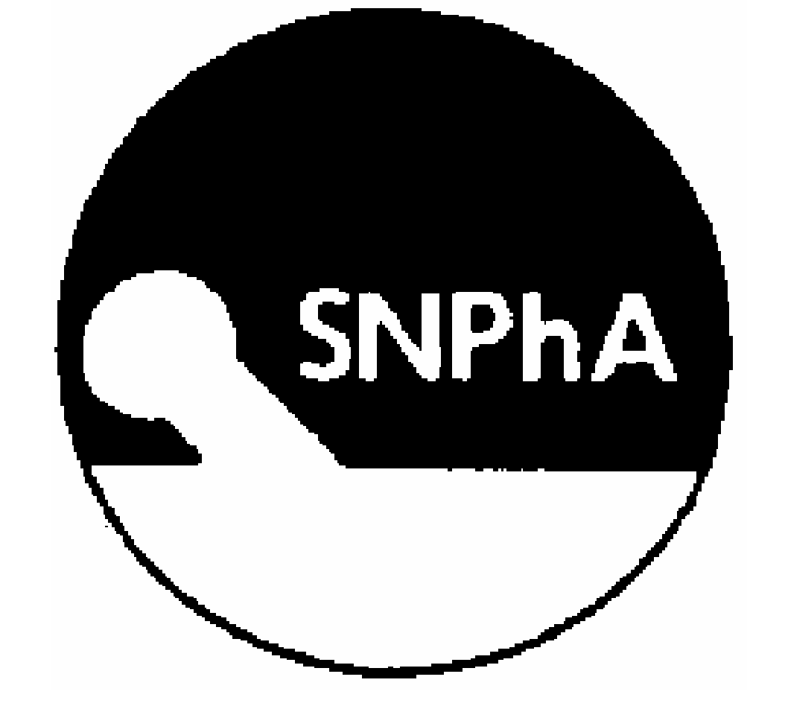

*at The Ohio State University*

**CONSTITUTION**

*June 19, 2005*

*Article l - Name, Purpose, and Non-Discrimination Policy of SNPhA.*

***Section 1: Name:***The student division of the National Pharmaceutical Association (NPhA) shall be called the Student National Pharmaceutical Association (SNPhA) at The Ohio State University.

***Section 2 - Purpose*:** SNPhA shall have the following purposes:

1. To offer student members the opportunity to develop leadership and professional skills.
2. To educate students about, and promote active participation in national healthcare issues.
3. To develop the role of the minority health professional as vital members of the healthcare team.
4. To develop within communities, a positive image of minority health professionals.
5. To educate communities on better health practices and to increase their awareness and understanding of diseases.

***Section 3 - Non-Discrimination Policy****:*

This organization and its members shall not discriminate against any individual(s) for reasons of age, color, disability, gender identity or expression, national origin, race, religion, sex, sexual orientation, or veteran status.

***Article II - Membership: Qualifications and categories of membership.***

Voting membership shall include any dues-paying pre-pharmacy undergraduate student or students pursuing a professional degree in Pharmacy (BS or PharmD), any student pursuing a degree in any of the allied health professions, or pharmacy graduate students pursuing Masters/Doctoral degrees at the Ohio State University. In addition high school students are eligible for affiliate membership. The SNPhA membership year is from August 1st through July 31st.

***Article III - Organization Leadership: Titles, terms of office, type of selection, and duties of the leaders.***

**Section 1. OFFICERS.** SNPhA officers shall be the President, President-Elect, Vice President, Secretary, Treasurer, Chapter Delegate, and Historian as well as any other committees appointed by the executive committee as necessary.

**Section 2. PRESIDENT.**

* Shall be the executive committee chair, preside over chapter meetings, delegate responsibilities, and act as the organizational spokesperson.
* The President shall present a report of SNPhA activities at the Annual Convention
* Shall serve as spokesperson for SNPhA to the NPhA Executive Committee.

**Section 3. PRESIDENT-ELECT.**

* The President-Elect shall serve as the membership committee chair; plan & coordinate several membership drives throughout the year
* They shall familiarize themselves with policies and procedures, then serve as president the following academic year
* They shall perform such duties that may be assigned periodically by the Executive Committee.

**Section 4. VICE PRESIDENT.**

* The Vice President shall serve as the professional committee chair
* Plan/coordinate the chapter’s participation at the regional & national meetings.
* Assist the president and perform the duties of the President in the absence of the President and as well as any duties that may be assigned periodically by the Executive Committee.
* Maintains the chapter test file bank

**Section 5. SECRETARY.**

* The Secretary shall serve as the publicity committee chair and maintain regular correspondence with chapters (i.e. delegates, local officers, and other necessary persons),
* Record and present minutes from meetings and other correspondence and written documents
* Assume responsibility for all outgoing and incoming chapter correspondence
* Check the chapter mailbox; report its contents to the general membership and respondings as such
* Maintain SNPhA Membership directory & Alumni Directory
* Submit all chapter reports as outlined in the Chapter Management Manual at <http://www.npha.net/snpha/SNPhAChapterManagementManual.pdf> (i.e. Chapter Registration Form, Bimonthly/Annual Reports)

**Section 6. TREASURER.**

* The Treasurer shall serve as the Fundraising and Finance committee chair
* The Treasurer shall coordinate disbursement of funds, maintain regular financial records, sign all checks, and complete written reports.
* The Treasurer shall present a written report to the membership at chapter meetings
* Work with other members of the executive committee to develop a budget
* Coordinate funding for Regional & National Meetings

**Section 7. HISTORIAN.**

* Shall serve as the scrapbook committee chair
* Shall photograph and document all chapter activities
* Maintain chapter bulletin board in Parks Hall outside room 107
* Coordinate and display a group photo
* Coordinate and maintain a chapter website and ensure that all information is correct & up to date

**Section 8. CHAPTER DELEGATE.**

* Shall prepare chapter report for the regional meeting, represent the chapter at the House of Delegate meeting during the national convention
* Reports regional meeting and national convention activities to local chapter members upon returning from these meetings

**Section 9. CHAPTER CHAIRS.**

* Must be present at all biweekly GBMs and events hosted by other chairs of the chapter, unless a valid excuse has been accepted via communication with the Vice President.
* Must meet their minimum yearly requirements of hosting chair activities as stated by the Vice President in order to retain their current position
* A CIC report for each event hosted must be completed and submitted to the Vice President for approval.
* All chairs must be due paying members of SNPhA upon election
* Re-election process will be deemed as necessary by the executive board with the consultation of the Advisor if roles and responsibilities of the position have not been met.

**Section 10. TREASURER ELECT.**

* Shall be in charge of GBM food reimbursement and responsible in setting yearly food budget.
* Assist the Treasurer with responsibilities of reimbursement, fundraising, and collecting dues for membership drive.
* Will assist the Treasurer in completion of the Dean’s Reimbursement Process.
* They shall familiarize themselves with policies and procedures, then serve as the Treasurer the following academic year.

**Section 11. TERM OF OFFICE.** Elected officers representing the Executive Committee shall be elected for a term of one (1) year from August 1st through July 31st and shall serve until their successors have been elected and installed. No individual shall serve more than one term as an elected officer in the same office. Leaders and general membership and are elected or appointed from the ranks of the organization’s voting membership.

**Section 12. VACANCIES.** The Vice President shall fill a vacancy in the office of the President. A SNPhA member appointed by the President and approved by the Executive Committee shall fill a vacancy in any office on a pro tem basis. Any member so appointed will fill the vacant office until a successor has been elected and installed.

**Section 14. REMOVAL OF OFFICERS.** If an elected officer fails to fulfill their responsibilities as outlined in these Bylaws, engages in conduct detrimental to the organization, or violates the OSU Student Code of Conduct, they may be subject to removal. The removal process shall be as follows:

1. A written statement outlining the reasons for removal must be submitted to the executive board.
2. The officer in question will be given the opportunity to present their case before the executive board and advisor.
3. A vote will be conducted, requiring either:
   * A **two-thirds (2/3) majority** vote of the voting membership, **or**
   * A **unanimous vote** of the remaining executive board members, with advisor consultation.
4. If removed, the vacancy will be filled per the succession plan outlined in these Bylaws.

**Section 14. REMOVAL OF MEMBERS.** If a member conducts themselves in such a manner deemed detrimental to advancing the purpose of this organization or is in violation of the OSU Student Code of Conduct, they can be removed through a majority vote of the other voting membership or unanimous vote of the officers, with the consultation of the advisor.

**Section 15. PROCESS OF CHAIR ELECTION.** For Spring Chair Elections, applicants must be a returning or current member of SNPhA in order to qualify for a Chair Position. The selection process for ALL chairs (including Asian Free Clinic Chairs) will be delegated by the executive board and must be a unanimous vote during the Spring Chair Elections.

*Article IV - Executive Committee (if needed): Size and composition of the Committee.*

**Section 1. COMPOSITION.** The Executive Committee shall consist of the officers. The executive committee shall be composed of the president, president-elect, vice president, secretary, treasurer, public relations liaison, chairpersons of standing committees, and ex officio positions from related student organizations as necessary.

**Section 2. DUTIES AND AUTHORITY.** The Executive Committee shall conduct the business of the association and determine all SNPhA programs and activities including the Annual Convention. The executive committee shall represent the general membership, conduct business of the organization between general meetings of the membership, and report its actions at the general meetings of the membership**.**

**Section 3. QUORUM.** Three voting members of the Executive Committee shall

constitute a quorum for the transaction of business.

**Section 4. VOTING.** Any question, which might be decided by vote, can be taken at the Executive Committee meeting, or decided by vote taken by mail, electronic mail, telegraphic or telephone ballot.

***Article VI – Adviser(s) or Advisory Board: Qualification Criteria.***

Advisers of student organizations shall be full-time members of the University faculty or Administrative & Professional staff. If a person is serving as an adviser who is not a member of the above classifications, a co-adviser shall be chosen who is a member of these University classifications. The advisor shall provide direction and guidance to the chapter. The SNPhA chapter advisor plays a key role in the functioning and progress of the chapter. The advisor helps the organization in several ways:

* Serves a liaison between the school’s faculty/administration and the chapter
* Provides continuity from year to year
* Promotes a link between the local chapter and National Headquarters
* Serves as a contact to receive bulk materials from National Headquarters for dissemination to the chapter
* Serves as a role model for students
* Supervises fiscal accountability of the chapter
* Manages student’s completion of tasks and activities
* Provides counsel and advice as necessary to assist the chapter in fulfilling projects and hosting regional meetings.

***Article VII – Meetings of the Organization: Required meetings and their frequency.***

SNPhA shall hold at least 3 general meetings and 3 executive committee meetings each academic quarter except for summer quarter. The executive committee shall meet at least once in the summer quarter before the end of their term on July 31st.

***Article VIII – Method of Amending Constitution: Proposals, notice, and voting requirements.***

Proposed amendments shall be made in writing, read in the general meeting in which they are proposed, shall be read again at a second general meeting and again at the third general meeting at which a vote shall be taken. A two-third or three-quarter majority of voting members (a quorum of 3 being present) or a majority or two-thirds of the entire voting membership of the organization, present or not, shall be required to pass an amendment to the constitution.

# ***Article IX – Method of Dissolution of Organization***

Any proposal to dissolve the Student National Pharmaceutical Association at the Ohio State University shall be made in writing, read in the general meeting in which it is proposed, shall be read again at 4 additional general meetings for discussion and consideration, and again at the 6th general meeting at which a vote shall be taken. A three-quarter majority of voting members (a quorum of 4 being present) or a majority or two-thirds of the entire voting membership of the organization, present or not shall be required to pass a proposal to dissolve

The treasurer shall pay any outstanding debts in the event of dissolution and liquidate/transfer any assets to the dean’s match fund of the Ohio State University College of Pharmacy at the discretion of the president and faculty adviser.

***Article X – Non-Discrimination Clause***

The Student National Pharmaceutical Association (SNPhA) is committed to fostering an inclusive, equitable, and respectful environment. This organization does not tolerate discrimination or harassment on the basis of age, ancestry, color, disability, gender identity or expression, genetic information, HIV/AIDS status, military status, national origin, race, religion, sex, sexual orientation, protected veteran status, or any other characteristics protected under applicable law.

This commitment applies to all activities, programs, membership, and leadership opportunities within the organization. SNPhA stands firmly against any form of prejudice or exclusion and actively works to promote diversity and inclusivity in every aspect of its mission and operations.