**ColorStack at Ohio State Constitution**

**Article I: Name**

The name of the organization shall be ColorStack at Ohio State

**Article II: Purpose**

ColorStack’s mission is to increase the number of Black and Latinx Computer Science graduates that go on to start rewarding technical careers.

**Article III: Membership**

**Section I**

1. Membership must be open to currently registered, matriculated undergraduate students of Ohio State who have paid the undergraduate student activity fee and must subscribe to, or be interested in the purpose of this organization.
2. No person shall be denied membership or office because of sexual orientation, nation of origin, race, sex, and physical disability, political or religious beliefs, and all other protected classes under federal and state laws.

**Section II**

1. Members shall be recognized as active after filling out our roster form and attending one general body meeting.

**Section III**

1. If this organization charges any monetary dues, there will be exceptions made for students that cannot afford these dues.

**Article IV: Executive Board and Officers**

**Section I: General Requirements**

1. All nominees for executive board positions must have a minimum, cumulative grade point average of 2.25 and if elected, must maintain a cumulative grade point average of 2.25 and must be a registered, matriculated student for the semester(s) during which they are to serve.
2. All officers shall serve for the semester and must be re-elected at the end of their term, as long as they maintain a cumulative grade point average of 2.25 and remain as a registered, matriculated student each semester

**Section II: Organization**

1. The members of the executive board shall be President, Vice President, Treasurer, Secretary, Events Chair, Communications Chair, and Corporate Director.
2. The total membership of the executive board shall not exceed members of the organization

**Section III: President**

1. The President shall be the official representative of the organization; they shall also be a non-voting, ex-officer member of all committees of the organization.
2. The President shall have the power to convene and preside over the meetings of the executive board and the general body, as well as prepare the agenda for the respective meetings.
3. The President shall further perform duties, as may be necessary and proper in the fulfillment of their office, subject to the approval of the executive board.

**Section IV: Vice President**

1. The Vice President shall be responsible to see that standing committee chairpersons are fulfilling their duties.
2. The Vice President shall be responsible for the technical and electronic duties, including but not limited to being the primary contact for the organization.
3. The Vice President shall further perform such duties, as may be necessary and proper in the fulfillment of their office, subject to approval of the executive board.
4. In the event that the President is unable to perform their duties (due to leave of absence, resignation, or impeachment), the Vice President shall assume the powers and responsibilities of the Presidency until a new President can be elected.
5. In the event that the Vice President is unable to perform their duties (due to leave of absence, resignation, or impeachment), a new Vice President will be elected in a special election called by the President.

**Section V: Treasurer**

1. The Treasurer shall keep a detailed record of all monies allotted to and raised by the organization.
2. The Treasurer shall perform such duties, as may be necessary and proper in the fulfillment of their office, subject to the approval of the executive board.
3. In the event that the Treasurer is unable to perform their duties (due to leave of absence, resignation or impeachment), a new Treasurer will be elected in a special election called by the President.

**Section VI: Secretary**

1. The Secretary shall take minutes and attendance of all meetings and maintain an up-to-date active voting membership roster.
2. The Secretary shall send out a weekly email, which outlines the agenda of the upcoming meeting, one school day prior to the meeting.
3. In the event that the Secretary is unable to perform their duties (due to leave of absence, resignation, or assumption of the presidency), a new Secretary will be elected in a special election called by the President.

**Section VII: Operations Chair**

1. Book rooms and order food for events
2. Manage club membership

**Section VIII: Academic Chair**

1. Collect and organize all key exam dates and deadlines for internal awareness
2. Plan study sessions for exams
3. Crowdsource study material for courses
4. Keep track of all members that are course TAs for internal awareness
5. Plan weekly office hours for the entire club

**Section IX: Events Chair**

1. Mange the ideation, planning, and execution of all events
2. Coordinate between the owner of the event, the treasurer, and the operations chair to facilitate the execution of each event

**Section X: Professional Development Chair**

1. Share professional opportunities on a consistent basis
2. Coordinate with the events chair during recruiting season to plan events such as a resume review or conducting mock interviews.
3. Keep track of the professional activities that members are taking advantage of, especially during the summer

**Section XI: Communications Chair**

1. Manage the club’s social media accounts

**Section XII: Alumni Relations Chair**

1. Manage a database of all club alumni
2. Send out a recurring alumni update semesterly
3. Source financial and professional support from alumni

**Section XIII: Mentorship Director**

1. Organize a mentorship program for the club
2. Match upperclassmen with underclassmen annually
3. Hold mentors accountable for providing value to their mentee
4. Ensure that mentees are satisfied with their mentorship experiences

**Section XIV: Outreach Chair**

1. Plan social events for the chapter
2. Develop initiatives to reach out to freshmen and accepted students
3. Develop initiatives to reach out to students outside of computing-related majors

**Section XV: Corporate Director**

1. Facilitate the relationship between employers and the chapter
2. Source sponsorship money
3. Collect resumes from members to be sent to corporate sponsors

**Article V: Meetings**

1. This organization shall hold one general membership meeting once a month during a semester.
2. A quorum consisting of a majority of the total active members is necessary for the transaction of any business of all meetings
3. All meetings must have an agenda and give notice to members at least one school day prior.

**Article VI: Elections**

1. Officers of the Executive Board shall be determined by an election with the general body.
2. No person shall seek the position of President, Vice President, Treasurer or Secretary unless they have been an active member of this organization for at least two semesters prior to the semester when they would assume office.
3. No personal shall be elected to more than one executive board position at any given term.
4. All new officers must be elected by majority vote of active members present at the election.
5. Elections must be held no later than two weeks before the end of the current semester.
6. New officers shall assume their position after the semester they were elected in ends.

**Article VII: Impeachment**

1. Any officer may be brought up on impeachment charges if they are acting detrimental to the organization, or has disregarded the responsibilities of their office.
2. If a list of charges signed by three-quarters of the officers is submitted to the President, they must call for impeachment proceeding. If the President is being brought up on charges, the petition shall be submitted to the Vice President. Upon receipt of the petition, the President shall suspend the officer and prevent them from exercising all powers and voting rights pending the outcome of the impeachment proceedings.
3. After proper impeachment proceedings, the officer(s) charged may be impeached by a three-quarter vote of group members. If impeachment passes, the officer shall be removed from their position.
4. Special elections shall be held upon impeachment of:
   1. President, the Vice President shall assume the powers and responsibilities of the Presidency until a special election is held for a new President within a one-month period.
   2. Vice President, Treasurer or Secretary, a special election shall be held within a month period.

**Article VIII: Amendments**

1. Amendments to this constitution may be introduced from the floor at a general body meeting and must be submitted to the Secretary in writing.
2. All active members must be notified in writing at least five school days prior to a vote on the proposed amendment.
3. A two-thirds majority vote of the active members is necessary for the passage of an amendment.

**Article IX: Non-Discrimination Statement**

1. This organization does not discriminate on the basis of age, ancestry, color, disability, gender identity or expression, genetic information, HIV/AIDS status, military status, national origin, race, religion, sex, sexual orientation, protected veteran status, or any other bases under the law, in its activities, programs, admission, and employment.

**Article X: Member-Removal**

1. Members of ColorStack at Ohio State may be removed if they violate the organization's rules or act against its goals.
2. The executive board can set more rules for fair removal.

**Article XI: Dissolution**

1. In the event of the dissolution of this organization, all accrued funds and assets shall revert to the Undergraduate Student Government.

Signed by Primary Leader(President) Ephratah Meskel:

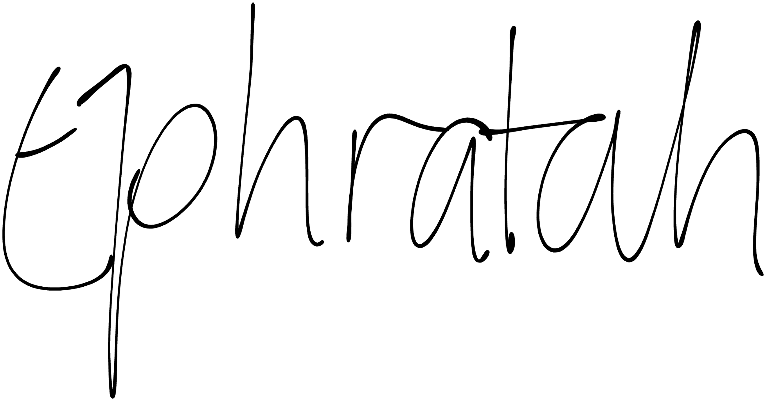

Signed by Secondary Leader(Vice-President) Ugonna Obiagwu:



Signed by Treasurer Mohamed Asmali:

