GradRoots Constitution

Article I Mission Statement / Statement of Purpose

Section 1 Mission
GradRoots is the official graduate student organization of the School of Environment & Natural Resources (SENR) at The Ohio State University. We are committed to serving the SENR graduate student populace by advocating for their needs, informing them of school and university policies and resources, providing academic and professional development opportunities, and building a sense of community within the school.

Section 2 Purpose
To advocate - Voice the needs and concerns of SENR Graduate Students
To inform - Inform students of important proposed and enacted policy changes, and university and school resources available for graduate students.
To develop - Provide relevant academic and professional development opportunities that will foster enhanced career potential among SENR graduate students.
To connect - Build a sense of community among graduate students, working to integrate students beyond their degree, specialization, and campus location.

Section 3 Non-Discrimination Policy
This organization and its members shall not discriminate against any individual(s) for reasons of age, ancestry, color, disability, gender identity or expression, genetic information, HIV/AIDS status, military status, national origin, race, religion, sex, sexual orientation, or veteran status. Furthermore, the GradRoots Board of Directors shall work to create an inclusive academic community for all GradRoots members by pursuing equity, justice, and fairness in all decisions, discourse, meetings, and activities, and by inviting voices and perspectives historically marginalized in academic and university settings.

Article II Membership

Section 1 General Membership
Membership in GradRoots shall extend to all currently enrolled graduate students in the School of Environment and Natural Resources, including students pursuing an MS or Ph.D. in Environment and Natural Resources, students pursuing a Masters of Environment and Natural Resources, as well as students in the Environmental Science Graduate Program (ESGP) who home unit is SENR. Membership is in parallel with enrollment in the above graduate programs. Other requests for membership shall be evaluated on a case-by-case basis by the GradRoots Board of Directors.

Section 2 Board of Directors Membership
All members of GradRoots (as defined above) who are in good academic standing are eligible to be nominated and elected to any position within the GradRoots Board of Directors. Some positions on the Board may have additional requirements or limitations as mentioned in the position descriptions in Article IV.

If the Board of Directors identifies a need for additional positions or a need to fill a vacant position within the Board between election cycles, the Board will propose and vote on the positions to be formed or filled, including the formation of any needed working committees to determine the description and duties of said position. The Executive Committee will inform general members of available interim positions and ask for applications. The full GradRoots Board of Directors will then vote on candidates deemed most suitable for the positions. Upon approaching the election period, the board should propose amendments to the constitution to formally establish the interim positions. Otherwise, the positions shall be terminated. These amendments should be added by a majority vote of the general membership. The general election ballot will proceed normally, with member nominations for officer positions being necessary for placement on the ballot.

Section 3 Standing Committee Membership
Standing Committees are groups focused on carrying out a specific purpose or facilitating a specific duty of GradRoots. All GradRoots members are eligible to be nominated and elected to chair an existing Standing Committee. Standing Committees may consist of any GradRoots members, Ohio State students, Ohio State faculty, alumni, or professionals whom the Standing Committee Chair feels are necessary for the standing committee to succeed in carrying out its purpose. Only the Standing Committee Chair is a voting member of the Board of Directors.

Article III Methods for Removing Members

Section 1 Removal of General Membership
A member will be removed from GradRoots if they lose graduate student standing within the University. Membership may also be revoked by a two-thirds affirmative vote by the Board of Directors in cases where a student is engaged in behavior that is in violation of the Ohio State University Student Code of Conduct or is otherwise a cause for dismissal from the Graduate Program. This behavior includes but is not limited to harassing another member, being disrespectful or disruptive, misrepresenting the organization or its purpose, and conducting themselves in a generally unethical manner.

Section 2 Removal of a Board of Director Membership
Any member of the Board of Directors or a Standing Committee may be removed for sufficient cause. Sufficient cause for removal includes but is not limited to: violation of the constitution or by-laws or any conduct deemed prejudicial to the best interests of GradRoots. Prior to a vote on the matter of removal of an elected officer, the chapter Executive Committee shall hold a formal hearing. The officer shall have the opportunity to personally appear at the formal hearing or to be represented by counsel. The officer may present any defense to the charges before any action is taken. The chapter Executive Committee shall adopt rules to ensure due process to the officer. The Executive Committee may act for removal upon a two-thirds affirmative vote of the Executive Committee.

Article IV Organization Leadership – Board of Directors
To effectively facilitate the mission and purposes of GradRoots and its members, a Board of Directors (hereafter “Board”) shall be elected which reflect the following organizational structure and duties.
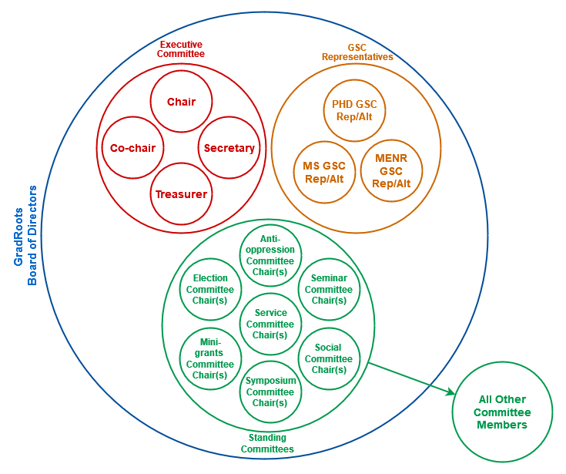
The Board consists of the Executive Committee, the Graduate Studies Committee (GSC) Representatives, and all Standing Committee Chairs. These roles are all necessary for the full functioning of the GradRoots organization; however, at a minimum, the Executive Committee positions must be filled.

All Board members are to organize in support of mission and purposes of GradRoots, promote GradRoots to other SENR graduate students, regularly attend meetings, participate in events and actions, and support the continuation of the GradRoots organization.
.

Article V Executive Committee
The Executive Committee is generally responsible for the supervision and administration of the GradRoots Board activities and duties. The Executive Committee will consist of a Chair, Co-chair, Secretary, and Treasurer.

The Executive Committee shall meet regularly and will be charged with developing meeting agendas, facilitate meetings, record meeting minutes, and communicate decisions made by the Board to GradRoots members.

Chair: The Chair is primarily the chief executive officer of GradRoots. Duties include organizing and facilitating meetings with the Board, facilitates communication with the GradRoots members through managing the listserv account, and communicating with administration and faculty about GradRoots activities. Finally, the chair is also responsible for maintaining GradRoots status as a club with the University by updating the organizations’ goals, membership, and leadership roles.

Co-Chair: The Co-chair position shares many responsibilities with the chair. This person works closely with the chair to ensure meetings, emails, and events all go smoothly. The Co-chair will stand in for the Chair in case of their absence.

Secretary: The Secretary will take attendance at all meetings, record and prepare minutes of meetings, upload meeting minutes to the GradRoots folder, distribute the agenda prior to Board meetings with the assistance of the Chair and Co-chair.
Treasurer: The Treasurer manages the GradRoots bank account, budget, financial transactions, reimbursements, and financial recordkeeping. In general, the Treasurer is expected to be familiar with the GradRoots funding available and advise the group on allowable expenses.
More detailed information and descriptions of Executive Committee duties and responsibilities are included in the GradRoots Handbook.

Article VI Committees

Section 1 Graduate Studies Committee Representatives
As the official graduate student organization, GradRoots works closely with the SENR Graduate Studies Committee (GSC) to manage the SENR graduate programs. To do this, GradRoots elects three representatives to positions within the GSC: a PhD representative, a MS representative, and a MENR representative, each with an alternate in case of absence. Each representative is a full voting member of the GSC.

GSC Representatives are required to attend all GSC bi-weekly meetings.

Section 2 Standing Committees
In order to successfully achieve the GradRoots mission, standing committees shall have specific duties as follows:

Social Committee: The purpose of the Social Committee is to create a sense of community within SENR, which the Committee shall achieve by coordinating social events with the GradRoots Board, promoting these events to the GradRoots general members, and facilitating these events. This committee is to be composed of at least two members.

Seminar Committee: The purpose of the Seminar Committee is to provide opportunities for GradRoots members to learn from and connect with experts in the field, which the Committee shall achieve by recommending speakers for the Environment and Natural Resources Seminar and facilitating interactions between GradRoots members and seminar speakers. This committee is to be composed of at least two members.

Mini-Grants Committee: The purpose of the Mini-Grants Committee is to encourage and support graduate student research and scholarship by awarding small competitive grants, which the Committee shall do by soliciting and evaluating applications in the spring and fall semesters. This committee is to be composed of four members (ideally, of different disciplines and graduate levels).

Election Committee: The purpose of the Election Committee is to maintain the GradRoots organization, which the Committee shall achieve by soliciting nominations for Board members, facilitating general elections, and ensuring a smooth transition between Board members. This committee is to be composed of at least one member.

Service Committee: The purpose of the Service Committee is to contribute to and connect with the local community, which the Committee shall achieve by identifying opportunities for GradRoots members to be of service to SENR, OSU, Columbus, and Ohio communities. This committee is to be composed of at least one member.

Anti-Oppression Committee: The purpose of the Anti-Oppression Committee is to center anti-oppression work in GradRoots culture and operations, which the Committee shall achieve by organizing educational workshops, providing feedback on policy changes, and proposing speakers for the seminar series. This committee is to be composed of 3-5 members.

Section 3 Establishing a New Standing Committee
To form a new standing committee, the Board of Directors must propose a constitutional amendment for a general vote. This proposal should include a description of the committee goals, responsibilities, and desired number of members.

Article VII Advisors

GradRoots must have at least one advisor, who must be a full-time member of the University faculty or Administrative & Professional staff. If a person is serving as an advisor who is not a member of the above classifications, a co-advisor must be chosen who is a member of these University classifications. The advisor must meet University requirements for advisors, including but not limited to attending advisor training every two years.

The GradRoots advisor may be asked to intellectually contribute to GradRoots actions, including but not limited to proposed events, activities, decisions, and documents. This may require attending Board meetings as requested. The GradRoots advisor may also be asked to attend some events. The GradRoots Board of Directors maintains the ability to meet without the presence of the advisor.

The GradRoots advisor shall serve as advisor in infinitum until such time that they are no longer willing or able to fulfill the duties of the role (in which case the advisor must provide 30 days of advance notice), or that the Board decides by two-thirds affirmative vote to seek a different advisor. Potential advisors shall be selected by the Board and asked if they are willing to serve as the advisor for GradRoots.

Article VIII Meetings
GradRoots general meetings will be held at least once in both the spring and fall academic terms. Attendance of all GradRoots members at these meetings is highly encouraged, but not required. These meetings will serve as a town hall for SENR graduate students to express their thoughts, questions, and concerns.

Board of Directors meetings will be held at least twice per month during the spring and fall academic terms. All members of the Board of Directors must attend these meetings – multiple absences may result in removal from the Board. An Executive Committee member must be present to preside over any meeting where a vote is called on official business; this is the responsibility of the Chair, but if they are absent, any Executive Committee member may preside over the meeting. Inasmuch as is possible, all formal business, voting, spending and strategic planning shall take place at regular meetings; however, three or more Board members may decide issues where time is of the essence and the full Board cannot be assembled. This provision shall be invoked only in extreme circumstances. Any GradRoots member may attend a GradRoots Board meeting and provide comments, but only Board members will be considered as voting members of Board meetings.
Relaxed Robert's Rules shall be followed at official meetings at the Board’s discretion to promote efficiency. The Chair shall call the meeting to order promptly at the scheduled start time and shall adjourn the meeting when all business has been addressed.
The following general agenda shall guide regular meetings:
1. Call to Order
2. Approval of Previous Minutes
3. Old Business
4. Committee Reports
5. New Business
6. Adjournment

Article IX Voting: Elections and Constitutional Amendments

Section 1 Elections
Elections for members of the Board of Directors, including the Executive Committee, Graduate Studies Committee Representatives, and Standing Committee Chairs, will be held once per year. The GradRoots Board will announce the upcoming elections and open nominations for each role. Any GradRoots member in good academic standing is eligible for any role. GradRoots members may nominate themselves or another member to fill any of the open positions. If there are insufficient nominees, it is the responsibility of the Board to seek nominees for open roles. Once the nomination period is closed, the Board will contact nominees to confirm their desire to run for the position. To confirm their desire to run, nominees must provide a short statement that will serve as their platform. This statement should describe why they are qualified for the position for which they are running and what their goals are for GradRoots. Prior to the end of the semester, the Board will share the names and statements of each candidate for each position and open voting. The candidate who receives a majority of votes will fill each position. All votes shall be tallied by the Secretary and entered into the official GradRoots records. A record of votes shall be kept by the Secretary that shall be accessible at all times by the membership with reasonable notice to the Secretary. Generally, the nominations and election period for all board positions occur in the same election cycle, at the end of Autumn Semester in November.

Section 2 Constitutional Amendments
This Constitution may be amended by a majority vote of GradRoots members. Proposed amendments will be detailed in writing and shared with GradRoots members via an email listserv. The amendment voting period shall take place over the course of one week but may be extended at the discretion of the Board or by request of any member for any reason, including but not limited to the magnitude of the proposed changes or insufficient voter turnout. Proposed amendments shall be included on the ballot for the election of members to the Board.

Article X Method of Dissolution of Organization

GradRoots can exist in some form as long as there at least an Executive Committee. In the event that there is an Executive Committee but not a full Board of Executives, it shall be the utmost priority of the Executive Committee to seek additional Board members. Should there come a time when GradRoots is unable to assemble an Executive Committee, the activities of the organization shall cease until an Executive Committee is able to be assembled. The responsibility of assembling an Executive Committee may then fall to SENR administration. In the absence of an Executive Committee, the departing Executive Committee members shall be responsible for transferring financial and physical assets to SENR administration to manage until such time that an Executive Committee and Board of Executives can be re-established.

