Instructions for In-Person Training Sign-Up Spring 2020

1. **Sign up for training on the Student Activities** [**website**](https://activities.osu.edu/involvement/student_organizations/training/)**:**
   1. Select the training date and time that you’d like to attend.  
      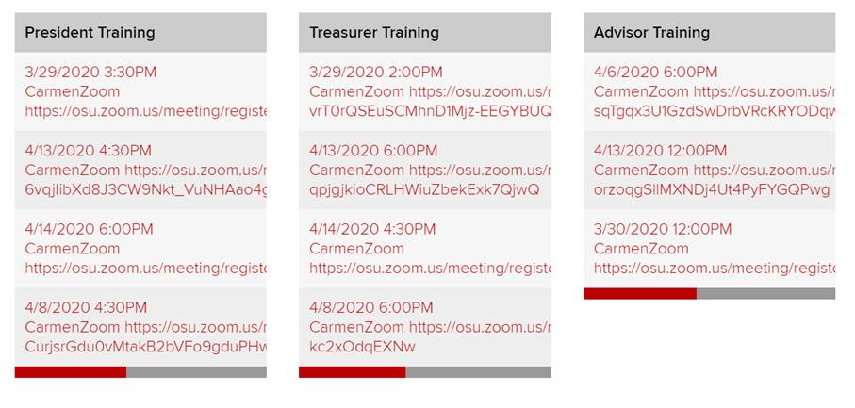
   2. Sign up for that session using your name.# OSU credentials.  
      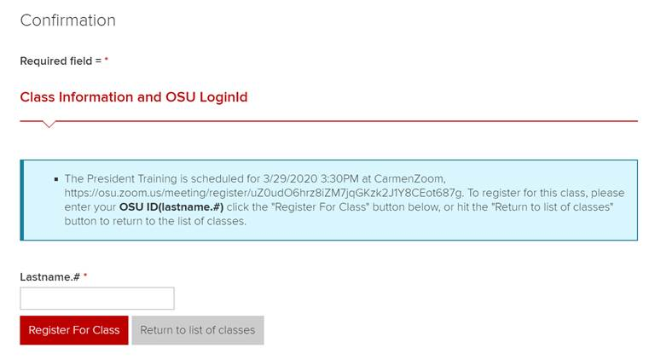
2. **Register for your session directly via Zoom to receive the access link you’ll need to attend the session.**
   1. You will get an email confirmation from the Center for Student Leadership and Service verifying your selection and providing you with a Zoom hyperlink to complete the registration.  
      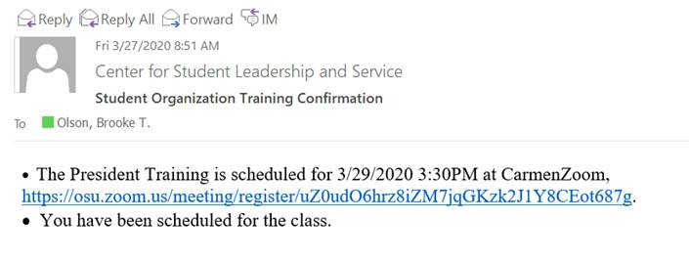
   2. Use the provided Zoom link to register through Zoom.  
      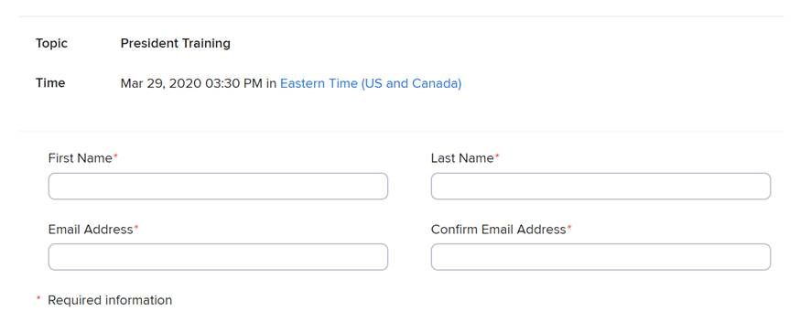
   3. You will then receive an email from Zoom that looks like this, which indicates that you have completely registered for training. You will use the Zoom hyperlink provided in this email to access the training at that specific date and time.  
        
      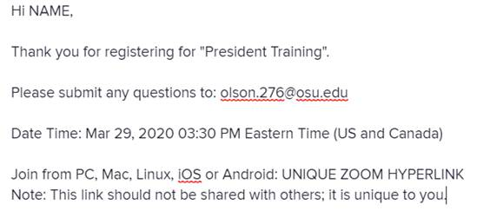

**Email our team at** [**csls@osu.edu**](mailto:csls@osu.edu) **if you have questions on this process. If you cannot find your final Zoom confirmation email with access link, please email our team at least 24 hours before your scheduled session, so we can re-send that email to you.**